College of Arts and Sciences

Offices of the Associate
and Assistant Deans

114 University Hall
230 North Oval Mall
Columbus, OH 43210

614-292-1667 Phone
asc.osu.edu

October 10, 2018

W. Randy Smith
Vice Provost for Academic Programs
Council on Academic Affairs
203 Bricker Hall
190 N. Oval Mall
Columbus, OH 43210

Re: BA-BS/DDS Conversion Proposal

Dear Randy:
The long-standing BA/DDS degree program at Ohio State was not converted at the time of our conversion from quarters to semesters and has been dormant since then. In response to student requests to the Dental School, Arts and Sciences and the Dental School have now been collaborating on converting and reviving that dual degree program, in which students could complete their bachelor’s degree while enrolled in the dental program.
I want to applaud the careful and conscientious work done by ASC Assistant Dean Deborah Haddad and the College of Dentistry’s Associate Dean for Academic Affairs, Darryl Hamamoto, to create the new semester version of this program, and to express here the College of Arts and Sciences’ strong support for approval of the semester version of the BS/DDS program.

Sincerely,
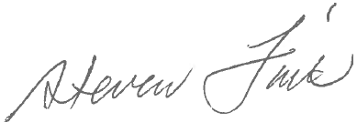
Steve Fink
Associate Executive Dean
College of Arts and Sciences
fink.5@osu.edu

